**Alert Manager Installation**

* Lets install alert manager on the same server where prometheus is running
* create a user called as alertmanager

sudo useradd --no-create-home --shell /bin/false alertmanager

* Lets create some folders for holding alert manager

sudo mkdir /etc/alertmanager

sudo mkdir -p /data/alertmanager

* Now Download & untar alertmanager

wget https://github.com/prometheus/alertmanager/releases/download/v0.23.0/alertmanager-0.23.0.linux-amd64.tar.gz

tar xzf alertmanager-0.23.0.linux-amd64.tar.gz

* Lets copy alertmanager amtool to /usr/local/bin

sudo cp amtool /usr/local/bin/

sudo cp alertmanager /usr/local/bin/

* copy the alert manager yaml file /etc/alertmanager/

sudo cp alertmanager.yml /etc/alertmanager

* Lets give permissions to alertmanager user

sudo chown alertmanager:alertmanager /usr/local/bin/{amtool,alertmanager}

sudo chown -R alertmanager:alertmanager /data/alertmanager /etc/alertmanager/*

* Lets create a systemd unitfile at /etc/systemd/system/alertmanager.service

[Unit]

Description=AlertManager

Wants=network-online.target

After=network-online.target

[Service]

User=alertmanager

Group=alertmanager

Type=simple

ExecStart=/usr/local/bin/alertmanager \

--config.file /etc/alertmanager/alertmanager.yml \

--storage.path /data/alertmanager

[Install]

WantedBy=multi-user.target

* Now enable and start the alertmanager

sudo systemctl enable alertmanager.service

sudo systemctl start alertmanager.service

sudo systemctl status alertmanager.service

* 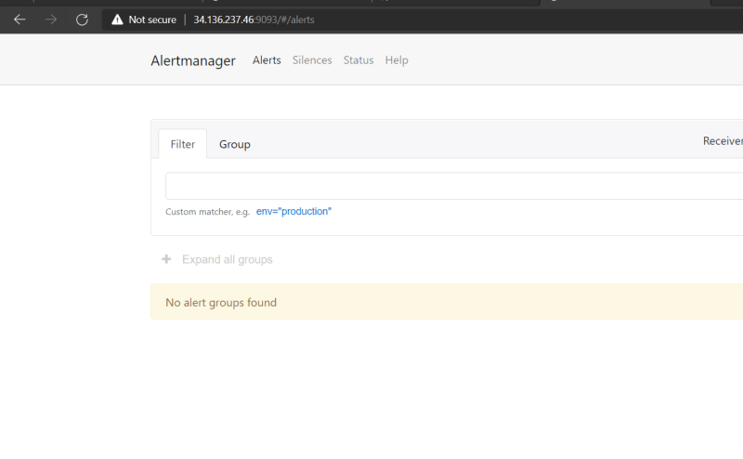
* We need to bind the alert manager to prometheus. Change /etc/prometheus/prometheus.yml to add the following section of alerts

global:

scrape_interval: 15s

alerting:

alertmanagers:

- static_configs:

- targets: ['localhost:9093']

scrape_configs:

- job_name: 'prometheus'

scrape_interval: 5s

static_configs:

- targets: ['localhost:9090']

- job_name: 'kubernetes'

static_configs:

- targets: ['10.128.0.31:30000']

* Now restart prometheus

sudo systemctl restart prometheus

* Now change the alert manager to add the email reciever

GNU nano 4.8 /etc/alertmanager/alertmanager.yml Modified route:

group_by: ['alertname']

group_wait: 30s

group_interval: 5m

repeat_interval: 1h

receiver: 'web.hook'

receivers:

- name: 'email'

email_configs:

- to: 'devops@qt.com'

from: 'alerts@qt.com'

smarthost: smtp.mailtrap.io:587

auth_username: 'jdsflksd'

auth_password: 'test'

- name: 'web.hook'

webhook_configs:

- url: 'http://127.0.0.1:5001/'

inhibit_rules:

- source_match:

severity: 'critical'

target_match:

severity: 'warning'

equal: ['alertname', 'dev', 'instance']

**Recording Rules**

* We can use recording rules to have prometheus evaluate PromQL Exressions regularly and ingest their results.
* This is useful to speed up your dashboards and provide aggregrated results for use elsewhere
* Recording rules got in seperate files from prometheus.yaml which can be specified in rule_files top_level filed in prometheus.yml file

global:

scrape_interval: 15s

rule_files:

- rules.yaml

alerting:

alertmanagers:

- static_configs:

- targets: ['localhost:9093']

scrape_configs:

- job_name: 'prometheus'

scrape_interval: 5s

static_configs:

- targets: ['localhost:9090']

- job_name: 'kubernetes'

static_configs:

- targets: ['10.128.0.31:30000']

* Sample rules.yaml

groups:

- name: example

rules:

- record: job:process_cpu_seconds:rate5m

expr: sum without(instance)(rate(process_cpu_seconds_total[5m]))

**Alerting**

* There is a set of community alerts created and hosted over here
* Lets create a alert-k8s.yaml in /etc/prometheus/alerts/k8s.yaml

groups:

- name: LearningK8s

rules:

- alert: KubernetesNodeReady

expr: kube_node_status_condition{condition="Ready",status="true"} == 0

for: 1m

labels:

severity: critical

annotations:

summary: Kubernetes Node ready (instance {{ $labels.instance }})

description: "Node {{ $labels.node }} has been unready for a long time\n VALUE = {{ $value }}\n LABELS = {{ $labels }}"

* prometheus.yaml

global:

scrape_interval: 15s

rule_files:

- 'alerts/k8s.yml'

alerting:

alertmanagers:

- static_configs:

- targets: ['localhost:9093']

scrape_configs:

- job_name: 'prometheus'

scrape_interval: 5s

static_configs:

- targets: ['localhost:9090']

- job_name: 'kubernetes'

static_configs:

- targets: ['10.128.0.31:30000']

* As of now we are able to get the alert in prometheus which gets forwarded to alert manager but we are not recieving email
* Note: I will try to look into this issue and we will create some alerts